FASt Data Abstract Form
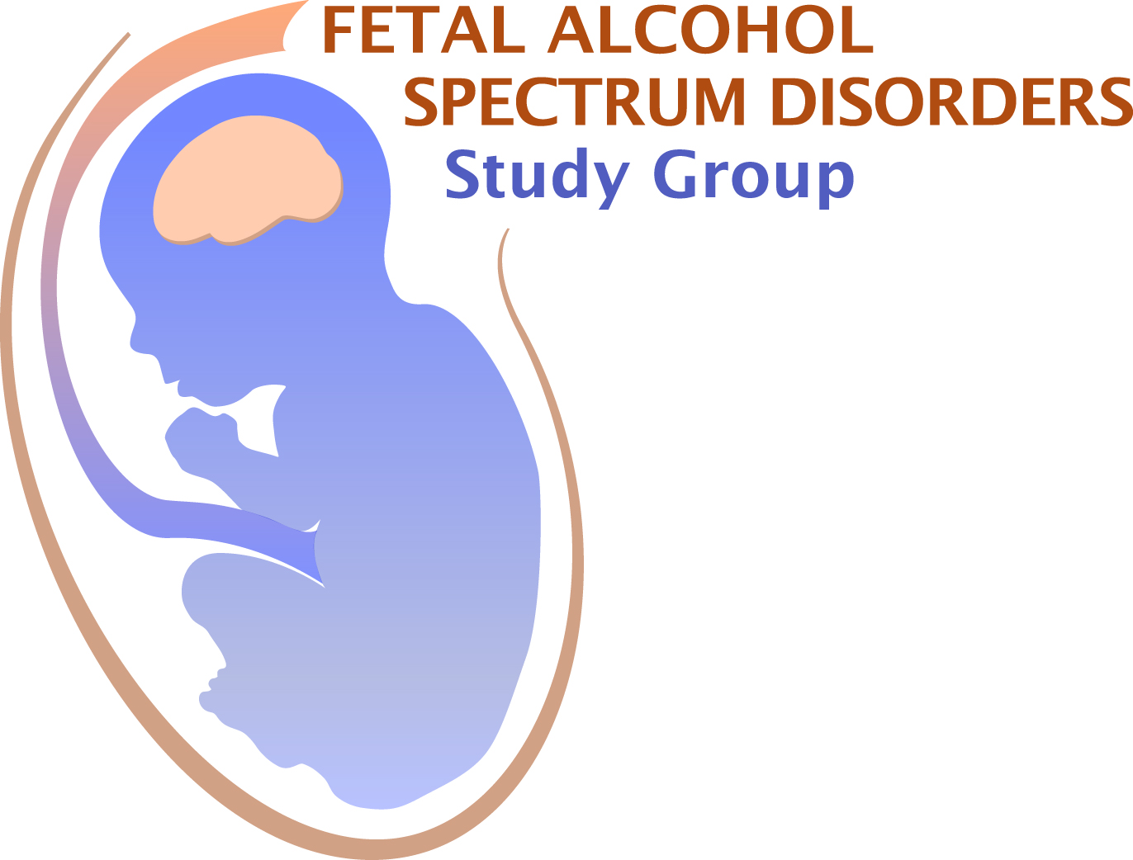
Application Deadline March 10, 2023
(two-slide, 5 minute talk)

Submit this completed form, together with the additional information noted below, to:
Dr. Jonathan Brigman at:
jbrigman@salud.unm.edu

First Name: Last Name: Degree:

E-mail address: Telephone:

Full Address & Affiliation:
Institution:
Department:
Mailing Address:
City: State: Country: Zip:

Current Status: Choose an item.

Are you a member of FASDSG? Yes ☐ No ☐
If you are a student or post-doc, is your mentor a member of FASDSG? Yes ☐ No ☐
If yes, Mentor’s Name:
For post-docs: are you within 4 years of your terminal degree? Yes ☐ No ☐
Is this abstract the same as your RSA abstract? Yes ☐ No ☐
Submission of RSA abstracts is allowed, however, priority for talks will be given to novel abstracts.
Do you want your abstract to be considered for a Trainee Award from FASDSG? Yes ☐ No ☐
Do you want your abstract to be considered for a Merit Award from FASDSG? Yes ☐ No ☐
If applying for an award, have you previously received one from FASDSG? Yes ☐ No ☐

AWARDS

Graduate students and postdoctoral fellows (less than 4 years past terminal degree) may apply for a Trainee Award and/or Merit Award. Trainee Award recipients will present a 5 minute FASt Data talk. The Merit Award recipient will present a 15 minute talk. Award applicant and mentor must be members of FASDSG.

For Trainee Research Award consideration, please submit this form (2 pages), your curriculum vitae, and a letter of recommendation from your advisor - who must be a member of FASDSG

For Merit Award consideration, please submit this form (2 pages), your curriculum vitae, a letter of recommendation from your advisor (who must be a member of FASDSG), and two additional letters of support

Instructions for application:
If submitting more than one abstract, please make a copy of this page for each abstract.
If applying for an award, assemble all the materials for your application in one PDF file and email as a single file to: jbrigman@umm.salud.edu by March 10, 2023. You will receive confirmation of receipt of your application.

Abstract Title:

Authors:

Institutional Affiliation/s:

Abstract (limit 360 words):
.
Source(s) of financial support for research:
Conflicts of interest: Yes ☐ No ☐
If you checked “yes”, please explain:

To apply for membership in FASDSG, contact Becky Thomas: beckyrsoa@gmail.com. You must already be a member of RSA https://researchsocietyonalcohol.org/becomeamember

