FASt Data Abstract Form
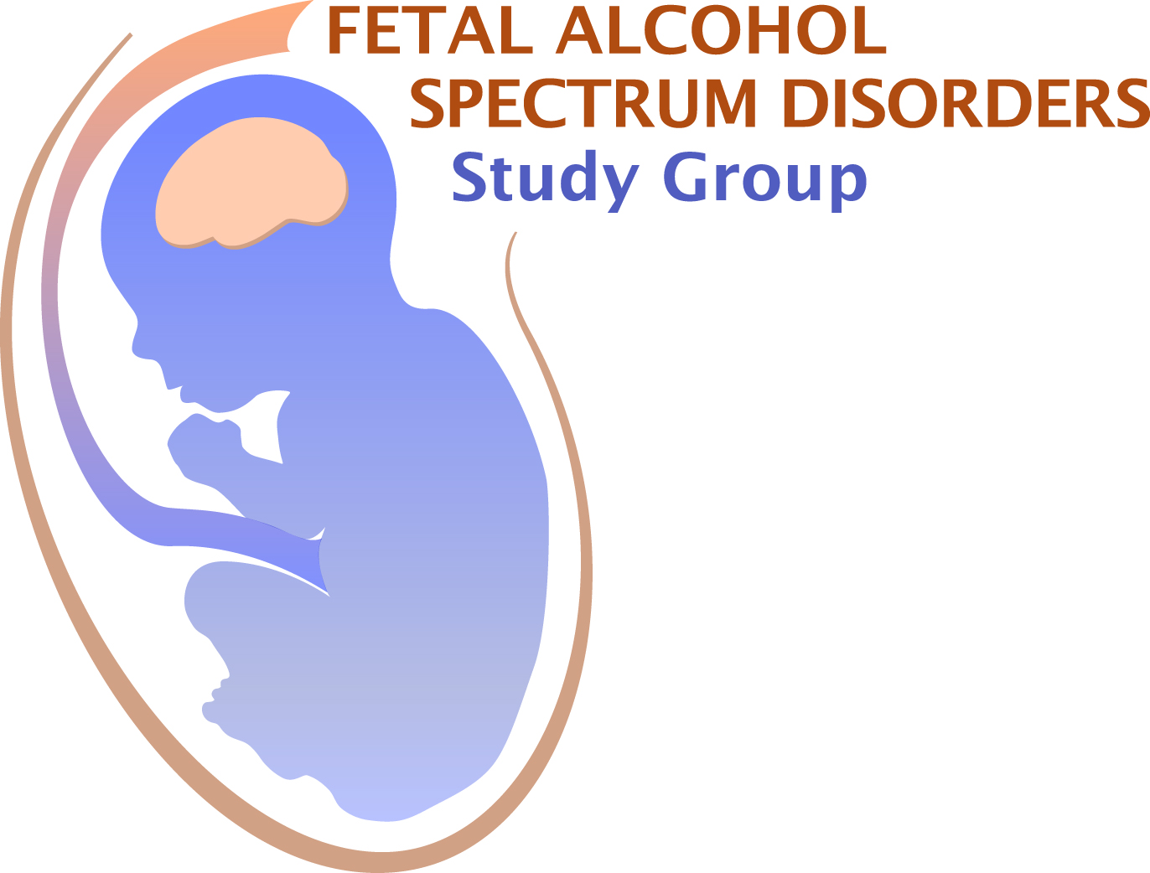
Application Deadline March 8, 2024
(two-slide, 5 minute talk)

Submit this completed form, together with the additional information noted below, to:
Dr. Scott Parnell at:
vicepresident@fasdsg.org

First Name: Last Name: Degree:

E-mail address: Telephone:

Full Address & Affiliation:
Institution:
Department:
Mailing Address:
City: State: Country: Zip:

Current Status: Choose an item.
Are you a member of FASDSG? Yes ☐ No ☐
If no, do you have a membership application submitted/pending approval Yes ☐ No ☐
If you are a student or post-doc, is your mentor a member of FASDSG? Yes ☐ No ☐
If yes, Mentor’s Name:
For post-docs: are you within 4 years of your terminal degree? Yes ☐ No ☐
Is this abstract the same as your RSA abstract? Yes ☐ No ☐
Submission of RSA abstracts is allowed, however, priority for talks will be given to novel abstracts.
Do you want your abstract to be considered for a Trainee Award from FASDSG? Yes ☐ No ☐
Do you want your abstract to be considered for a Merit Award from FASDSG? Yes ☐ No ☐
If applying for an award, have you previously received one from FASDSG? Yes ☐ No ☐
If you are not selected for a FASt Data Talk, do you want to be considered for a Poster Presentation that will occur during the day of the FASDSG meeting? Yes ☐ No ☐
AWARDS

Graduate students and postdoctoral fellows (less than 4 years past terminal degree) may apply for a Trainee Award and/or Merit Award. Trainee Award recipients will present a 5 minute FASt Data talk. The Merit Award recipient will present a 15 minute talk. Award applicant and mentor must be members of FASDSG. Pending memberships are acceptable as long as you have applied by the time of abstract submission.

For Trainee Research Award consideration, please submit this form (2 pages), your curriculum vitae, and a letter of recommendation from your advisor - who must be a member of FASDSG
For Merit Award consideration, please submit this form (2 pages), your curriculum vitae, a letter of recommendation from your advisor (who must be a member of FASDSG), and two additional letters of support
Instructions for application:
If submitting more than one abstract, please make a copy of this page for each abstract.
If applying for an award, assemble all the materials for your application in one PDF file and email as a single file to: vicepresident@fasdsg.org by March 8, 2024. You will receive confirmation of receipt of your application.

Abstract Title:

Authors:

Institutional Affiliation/s:

Abstract (limit 360 words):
.
Source(s) of financial support for research:
Conflicts of interest: Yes ☐ No ☐
If you checked “yes”, please explain:

To apply for membership in FASDSG, click on the link below. You must also be a member of RSA https://researchsocietyonalcohol.org/becomeamember.

