FASt Data Abstract Form
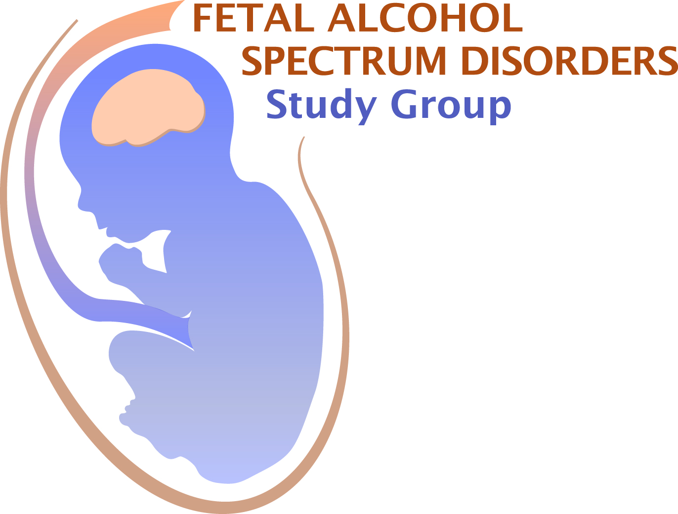
Application Deadline March 19, 2021
FASt Data abstracts can be for a talk (two-slide, 5 minute talk)
or for a poster

Submit this completed form, together with the additional information noted below, to:
Dr. Christie Petrenko at Christie_Petrenko@URMC.Rochester.edu

First Name: Last Name: Degree:

E-mail address: Telephone:

Full Address & Affiliation:
Institution
Department
Mailing Address
Address Line 2
State Country Zip

Current Status: Choose an item.

Are you a member of FASDSG? Yes ☐ No ☐
If you are a student or post-doc, is your mentor a member of FASDSG? Yes ☐ No ☐
If yes, Mentor’s Name:
For post-docs: are you within 4 years of your terminal degree? Yes ☐ No ☐
Is this abstract the same as your RSA abstract? Yes ☐ No ☐
Submission of RSA abstracts is allowed, however, priority for talks will be given to novel abstracts.
Do you want your abstract to be considered for a Trainee Award from FASDSG? Yes ☐ No ☐
Do you want your abstract to be considered for a Merit Award from FASDSG? Yes ☐ No ☐
If applying for an award, have you previously received one from FASDSG? Yes ☐ No ☐

AWARDS

Graduate students and postdoctoral fellows (less than 4 years past terminal degree) may apply for a Trainee Award and/or Merit Award. Trainee Award recipients will present a 5 minute FASt Data talk. The Merit Award recipient will present a 15 minute talk. Award applicant and mentor must be members of FASDSG.
For Trainee Award consideration, please submit this form (2 pages), your curriculum vitae, and a letter of recommendation from your advisor - who must be a member of FASDSG

For Merit Award consideration, please submit this form (2 pages), your curriculum vitae, a letter of recommendation from your advisor (who must be a member of FASDSG), and two additional letters of support

Instructions for application:
Use this form for talk and poster abstracts. If submitting more than one abstract, please make a copy of this page for each abstract.
If applying for an award, assemble all the materials for your application in one PDF file and email as a single file to: Christie_Petrenko@URMC.Rochester.edu by March 19, 2021. You will receive confirmation of receipt of your application.

Abstract Title:
Authors:
Institutional Affiliation/s:
Format Choose an item.
If not selected for a talk would you like to present this work as a poster? Yes ☐ No ☐
Abstract (limit 360 words):

Source(s) of financial support for research:
Conflicts of interest: Yes ☐ No ☐
If you checked “yes”, please explain:

To apply for membership in FASDSG, contact Becky Thomas: beckyrsoa@gmail.com. You must already be a member of RSA http://www.rsoa.org/becomeamember

