FASt Data Abstract Form
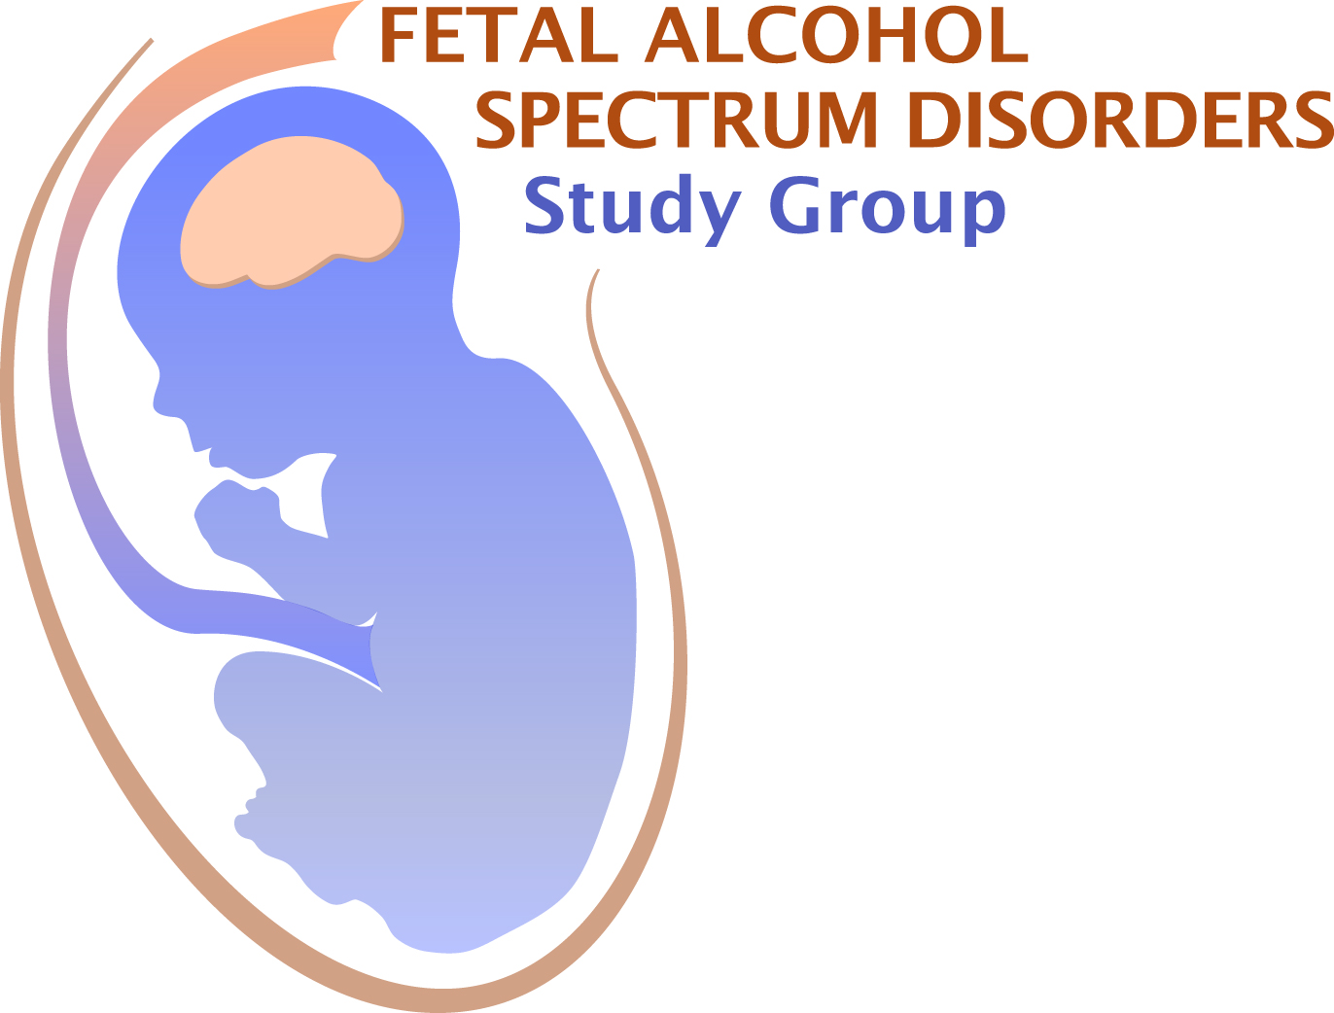
Application Deadline March 27, 2020
FASt Data abstracts are for a two-slide, 5 minute presentation

Submit this completed form, together with the additional information noted below, to:
Dr. Christie Petrenko at Christie_Petrenko@URMC.Rochester.edu

Last Name: First Name: Degree:

E-mail address: Telephone:

Full Address & Affiliation:
Institution
Department
Mailing Address
Address Line 2
State Country Zip

Current Status: Choose an item.

Mentor’s Name (If you are a Student or Postdoctoral Fellow):

Are you a member of FASDSG? Yes ☐ No ☐
If you are a student or post-doc, is your mentor an FASDSG member? Yes ☐ No ☐
For post-docs: are you within 4 years of your terminal degree? Yes ☐ No ☐
Is this abstract the same as your RSA abstract? Yes ☐ No ☐
Submission of RSA abstracts is allowed, however, priority will be given to novel abstracts.
Have you previously received an award from FASDSG? Yes ☐ No ☐

AWARDS

Graduate students and postdoctoral fellows (less than 4 years past terminal degree) may apply for a Travel Award and/or Merit Award. Travel Award recipients will present a 5 minute FASt Data talk. The Merit Award recipient will present a 15 minute talk. Award applicant and mentor must be members of FASDSG.
Do you want your abstract to be considered for a Travel Award from FASDSG? Yes ☐ No ☐
For Travel Award consideration, please submit this form (2 pages), your curriculum vitae, and a letter of recommendation from your advisor - who must be a member of FASDSG.

Do you want your abstract to be considered for a Merit Award from FASDSG? Yes ☐ No ☐
For Merit Award consideration, please submit this form (2 pages), your curriculum vitae, a letter of recommendation from your advisor (who must be a member of FASDSG), and two additional letters of support.

To apply for membership in FASDSG, contact Becky Thomas: beckyrsoa@gmail.com. You must already be a member of RSA http://www.rsoa.org/becomeamember
Instructions for application:
Assemble all of the materials for your application in one PDF file and email as a single file to: Christie_Petrenko@URMC.Rochester.edu by March 27, 2020. You will receive confirmation of receipt of your application.

Abstract Title:
Authors:
Institutional Affiliation/s:
Abstract (limit 360 words):

Source(s) of financial support for research:
Conflicts of interest: Yes ☐ No ☐
If you checked “yes”, please explain:

