FASt Data Presentation Form
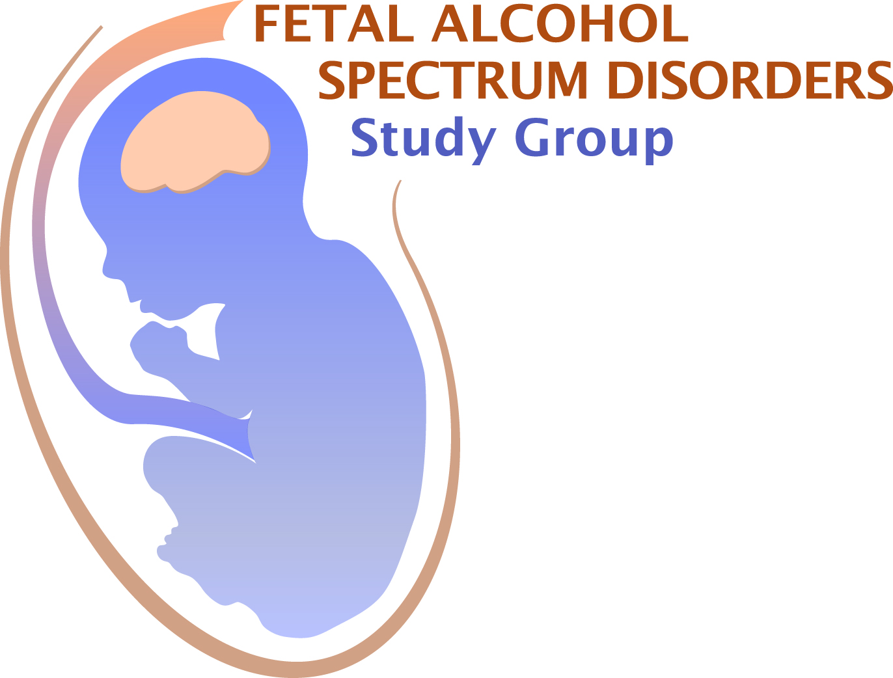
Application Deadline March 10, 2017

Submit this completed form, together with the additional information noted below, to:
Dr. Anna Klintsova at vicepresident@fasdsg.org

Last Name: First Name: Degree:

E-mail address Telephone

Full Address & Affiliation:
Institution:
Department:
Address Line 1:
Address Line 2:
State:

Current Status:
Graduate Student: Post-doctoral Fellow: Faculty/PI/Professional:

Mentor’s Name (Only if you checked “Graduate Student” or “Post-Doctoral Fellow”):

Are you an FASDSG member? Yes No

If you are a student, is your mentor an FASDSG member? Yes No

Is this abstract the same as your RSA abstract? (allowed) Yes No

FASt Data abstracts are for a two-slide, 5 minute presentation.
For FASt Data consideration, please submit the attached abstract form (page 2)

Graduate students and postdoctoral fellows may also apply for a Travel Award and/or Merit Award. Travel Award recipients will present a standard 5 minute FASt Data talk. The Merit Award recipient will present a 15 minute talk. Award applicant and mentor must be members of FASDSG.

Do you want your abstract to be considered for a Travel Award from FASDSG? Yes No
For Travel Award consideration, please submit the attached abstract form (page 2), your curriculum vitae, and a letter of recommendation from your advisor - who must be a member of FASDSG.
Do you want your abstract to be considered for a Merit Award from FASDSG? Yes No
For Merit Award consideration, please submit the attached abstract for (page 2), your curriculum vitae, a letter of recommendation from your advisor - who must be a member of FASDSG, and two additional letters of support.

(You may also apply for an RSA Travel Award, but you may only accept one travel award)

Instructions for application:
Assemble all of the materials for your application in one PDF file and email as a single file to: vicepresident@fasdsg.org by March 10, 2017. You will receive confirmation of receipt of your application. If you do not receive confirmation, please email Dr. Anna Klintsova at vicepresident@fasdsg.org

Abstract Title:
Authors:
Institutional Affiliation/s:
Abstract:

Significance (In 2-3 simple sentences, describe the significance of your research for a non-scientist audience):
Financial support for research:

Conflicts of interest: Yes No
If you checked “yes”, please describe those conflicts below:

